## **D**[**ocumentation**](https://github.com/Mohnifa/documentation-of-user-management-with-roles)

## **angular-10-signup-verification-boilerplate**

1. **clone the project source code from angular-10-signup-verification-boilerplate.**
2. **Open the angular-10-signup-verification-boilerplate in visual code.**
3. **Open terminal then install the angular-10-signup-verification-boilerplate.  
   After open src/app/.**
4. **Add folder role in the admin and copy the same from account to your role folder..**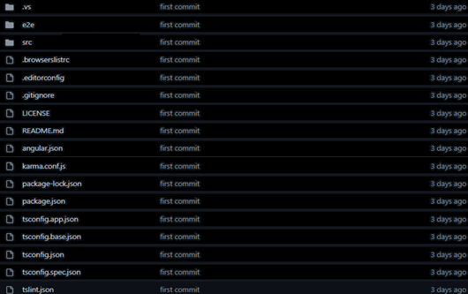  
   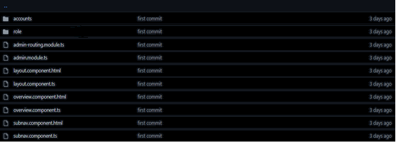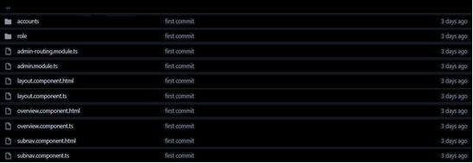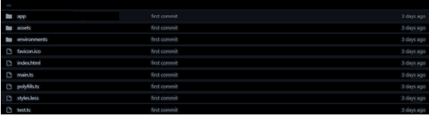
5. **Open admin-routing.module.ts**  
     
   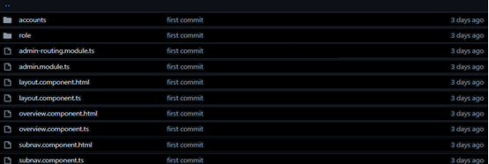  
     
   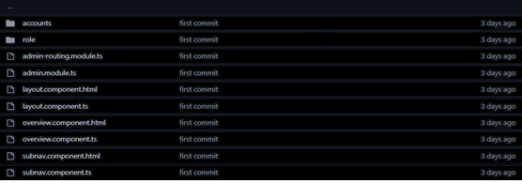  
   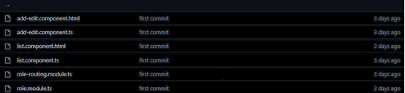  
   **then navigate to ’role’ and open the file role-routing.module.ts**
6. **Edit role-routing.module.ts**  
     
   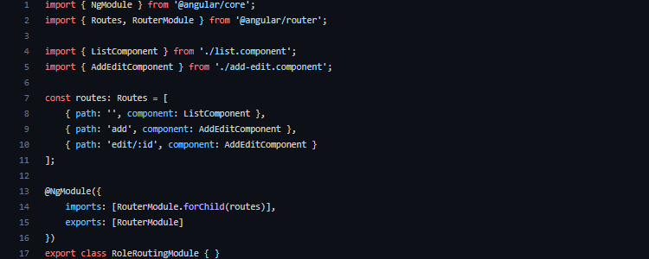
7. **Edit list.component.ts**  
     
   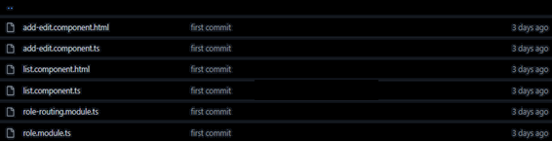  
   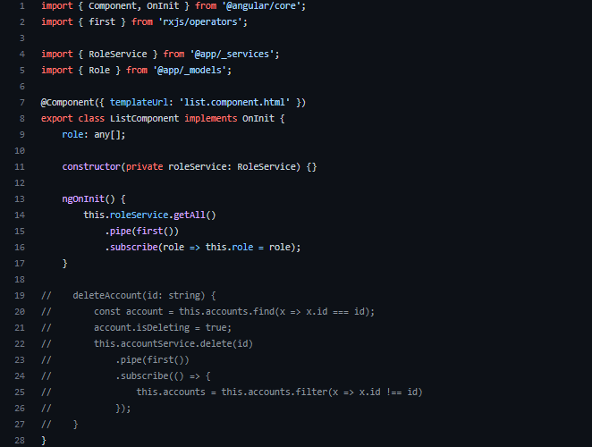

## **D**[**ocumentation of User Management with Roles**](https://github.com/Mohnifa/documentation-of-user-management-with-roles)

## **node-mongo-signup-verification-api**

Clone node-mongo-signup-verification-api and install it locally.  
  
Afteropen Github Website .  
Open vc.

Open node-mongo-signup-verification-api .

Copy the file of “account” and paste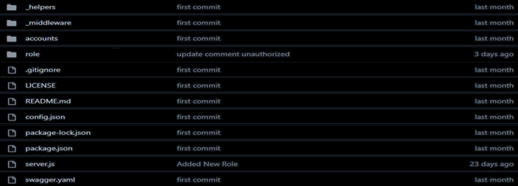

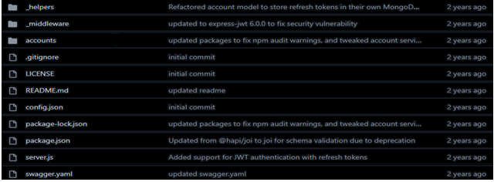

and rename it to role.

Open folder role.



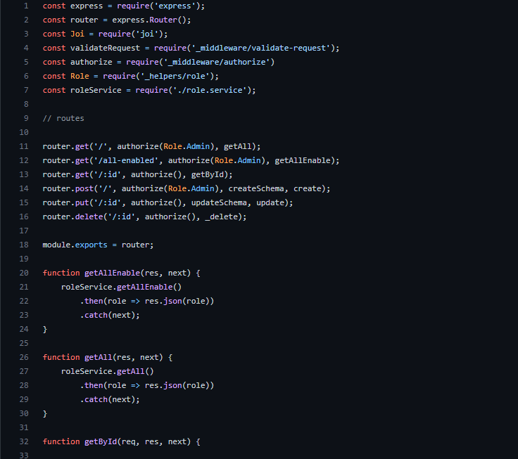

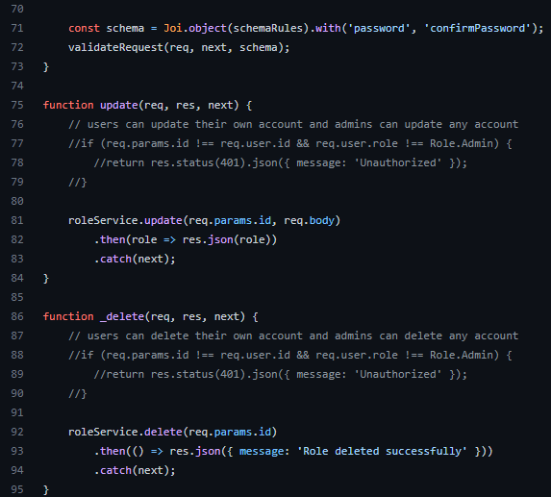

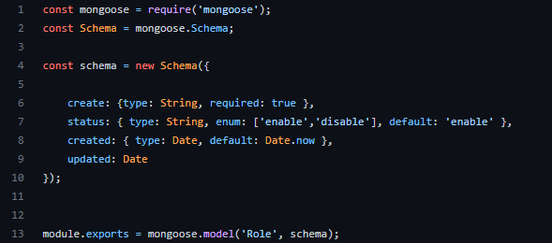

role.model.js

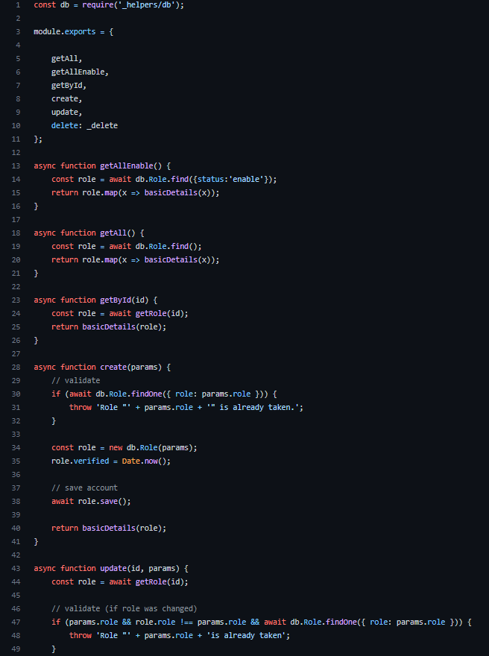

Role.service.js

